電通二乙微處理器實驗 實驗結報

實驗名稱 | Lab 01
組別 |  | 組員 | 林楷桓

- 實驗目的
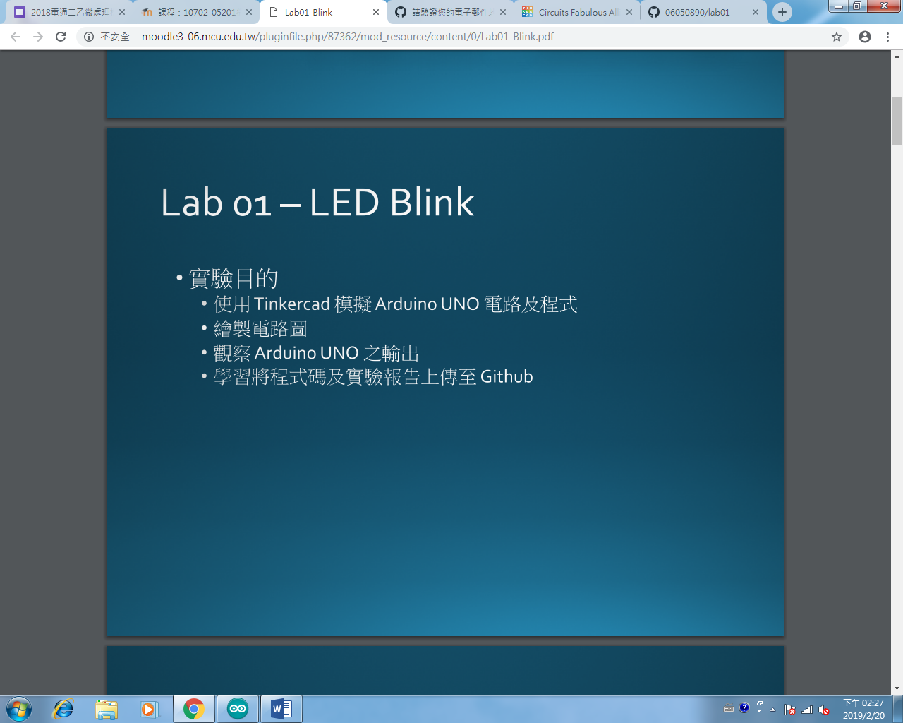
- 實驗步驟
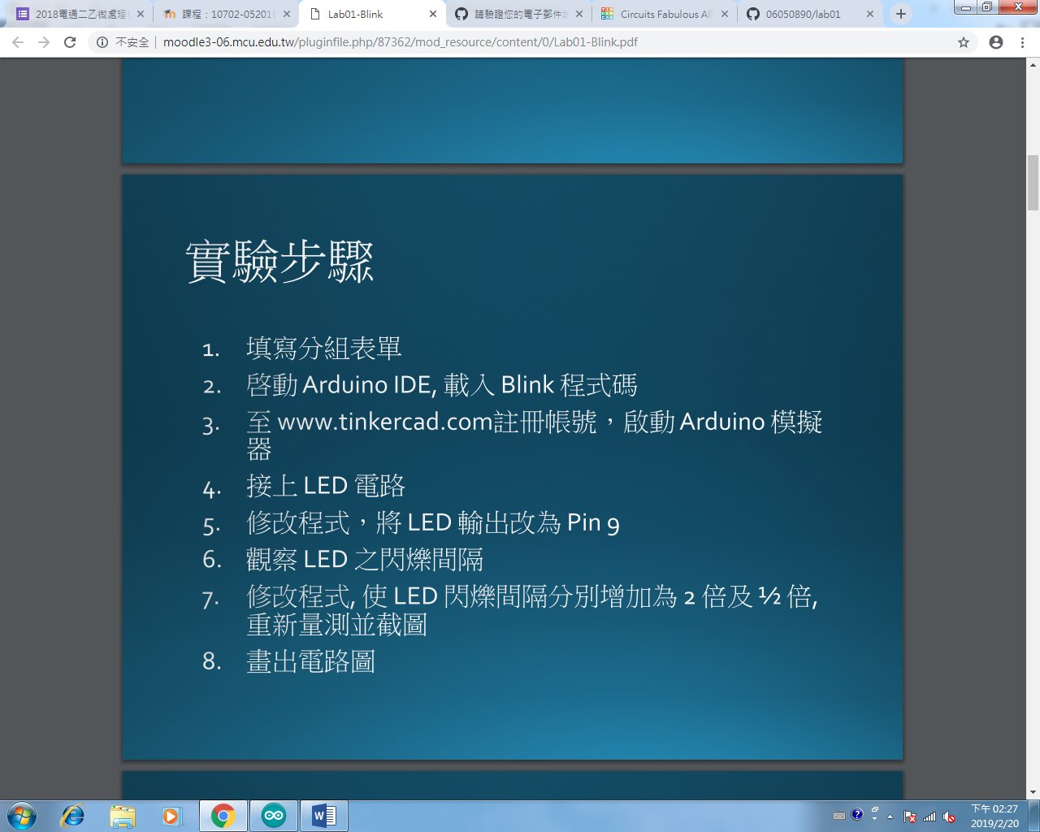

- 程式碼/修正程式碼
Check 1: 2倍1/2倍
void setup()
{
pinMode(9, OUTPUT);
}

void loop()
{
digitalWrite(9, HIGH);
delay(2000); // Wait for 1000 millisecond(s)
digitalWrite(9, LOW);
delay(2000); // Wait for 1000 millisecond(s)
}
void setup()
{
pinMode(9, OUTPUT);
}

void loop()
{
digitalWrite(9, HIGH);
delay(500); // Wait for 1000 millisecond(s)
digitalWrite(9, LOW);
delay(500); // Wait for 1000 millisecond(s)
}

Check 2: SOS
void setup()
{
pinMode(9, OUTPUT);
}

void loop()
{
digitalWrite(9, HIGH);
delay(100); // Wait for 1000 millisecond(s)
digitalWrite(9, LOW);
delay(100); // Wait for 1000 millisecond(s)
digitalWrite(9, HIGH);
delay(100); // Wait for 1000 millisecond(s)
digitalWrite(9, LOW);
delay(100); // Wait for 1000 millisecond(s)
digitalWrite(9, HIGH);
delay(100); // Wait for 1000 millisecond(s)
digitalWrite(9, LOW);
delay(100); // Wait for 1000 millisecond(s)

digitalWrite(9, HIGH);
delay(300); // Wait for 1000 millisecond(s)
digitalWrite(9, LOW);
delay(100); // Wait for 1000 millisecond(s)
digitalWrite(9, HIGH);
delay(300); // Wait for 1000 millisecond(s)
digitalWrite(9, LOW);
delay(100); // Wait for 1000 millisecond(s)
digitalWrite(9, HIGH);
delay(300); // Wait for 1000 millisecond(s)
digitalWrite(9, LOW);
delay(100); // Wait for 1000 millisecond(s)

digitalWrite(9, HIGH);
delay(100); // Wait for 1000 millisecond(s)
digitalWrite(9, LOW);
delay(100); // Wait for 1000 millisecond(s)
digitalWrite(9, HIGH);
delay(100); // Wait for 1000 millisecond(s)
digitalWrite(9, LOW);
delay(100); // Wait for 1000 millisecond(s)
digitalWrite(9, HIGH);
delay(100); // Wait for 1000 millisecond(s)
digitalWrite(9, LOW);
delay(100); // Wait for 1000 millisecond(s)

digitalWrite(9, LOW);
delay(300); // Wait for 1000 millisecond(s)

}

- 實驗結果及分析

check1 2倍、 1/2
2: 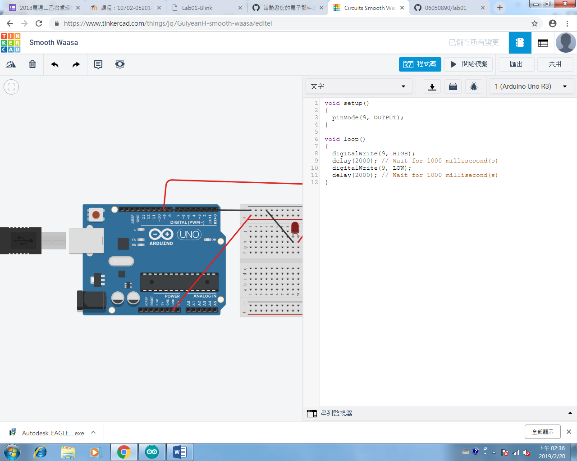

1/2: 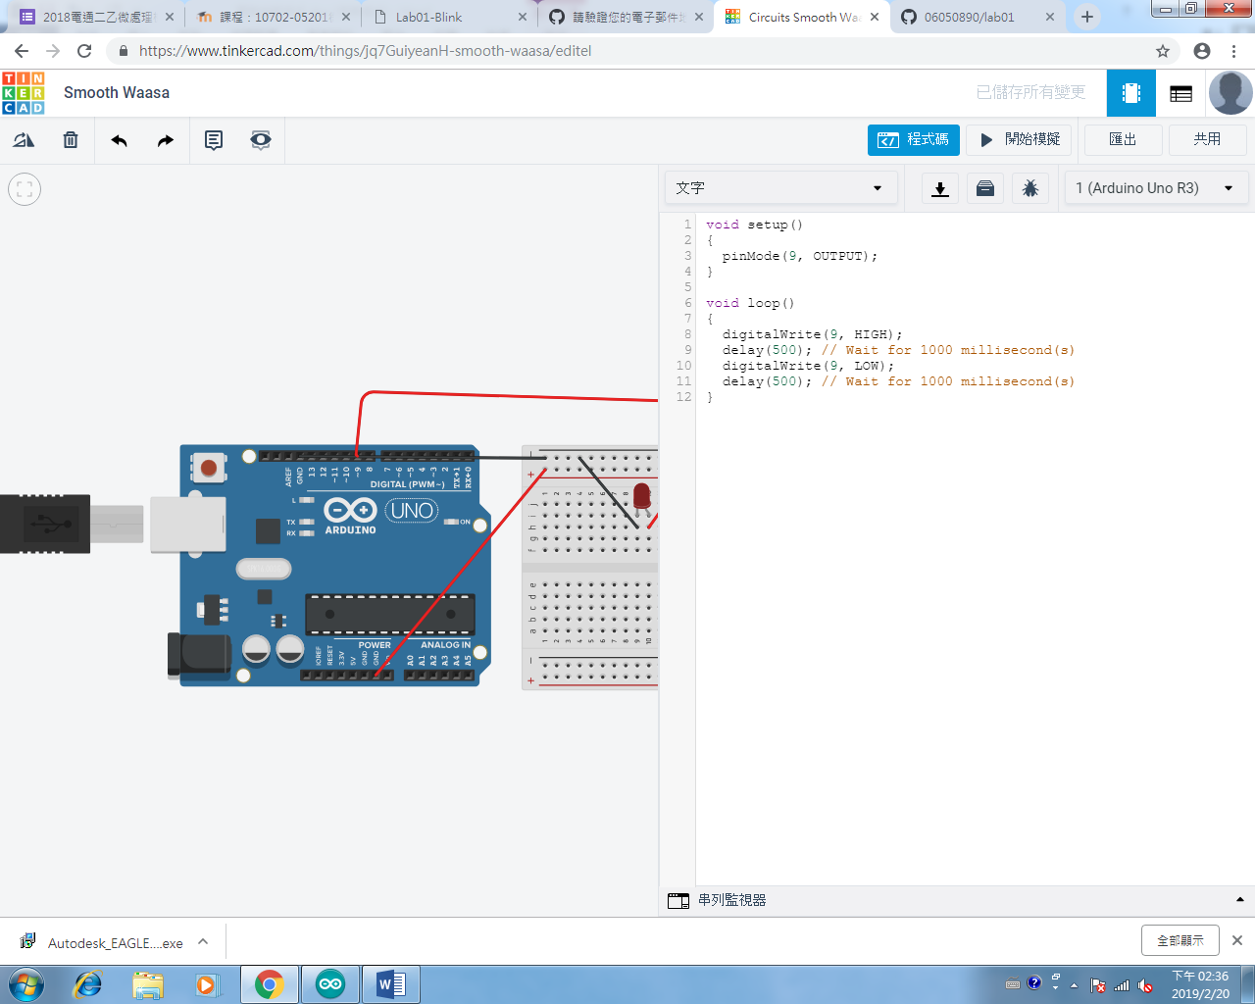

SOS: 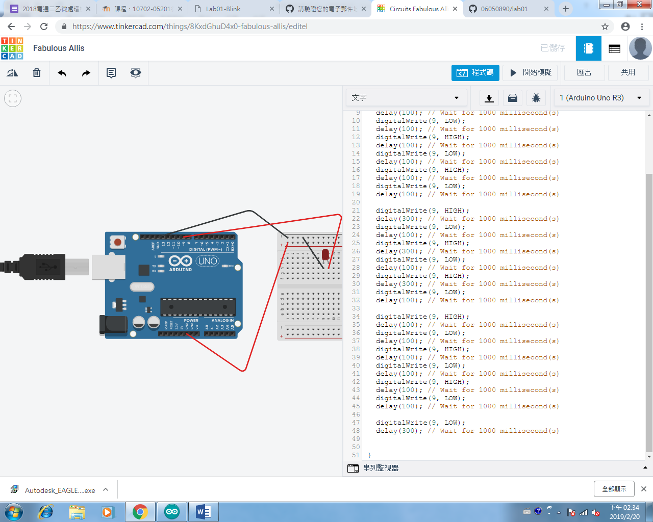
Check 2

- 心得討論:
第一次使用TINKERCAD ，覺得新奇，然後和同學討論，覺得好玩。
- 修正電路圖
